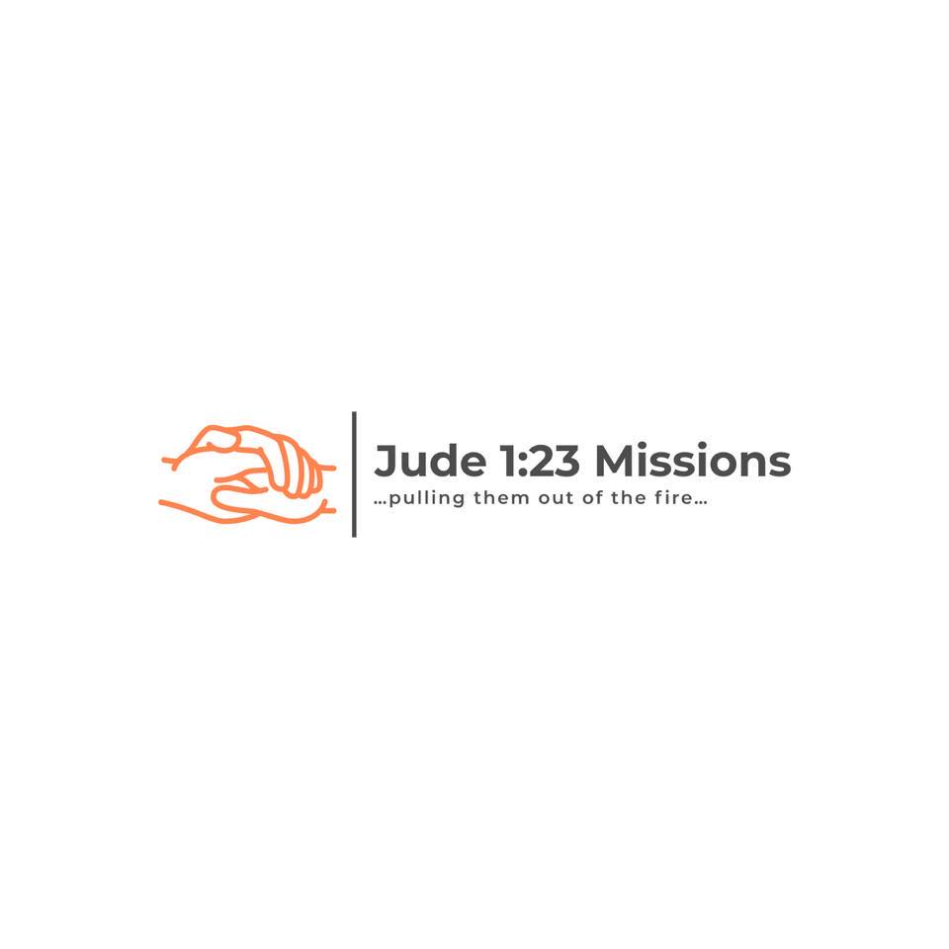

Sunday, August 8, 2021

Board Meeting Minutes

The meeting was called to order with all board members present. A sheet was passed collecting contact information for anyone in attendance with the desire to be a board member or member. The purpose of today’s meeting (going over and proofreading of the Articles of Incorporation) was stated and copies of said Articles were distributed to or shared among all those in attendance. The Articles of Incorporation needed to be approved via general consensus in order for the Articles of Incorporation to be emailed to Gibbs and Associates. They are a Christian law firm based out of Ohio. Once the Articles of Incorporation come back, the next step is to finish the 1023 form for the IRS application. A loose timeline of the return of the Articles of Incorporation was stated (2 to 3 weeks), as well as, a timeline for the approval of the 1023 form (3 to 6 months). The logo of the organization was shared. The address of the home base (Straight Mountain Baptist Church) was verified, and the mailing address (which is different that the church’s street address) was verified. While Nick did not read the entire narrative of the activities as laid out in the Articles of Incorporation, he did summarize the main purpose of the organization. The main focus is carrying the gospel to unreached people groups. While we may have to enter an area under the premise of sharing healthcare or other need, the focus will remain of the gospel. The name of the website Jude123.org and Facebook page was announced. An email account has been created specifically for the organization. The Board of Directors was announced as follows: Nick Logan, Ricky Statham, Cody Phillips, and Chuck Lacks. Everyone else in attendance was invited to be a regular member, and the opportunity may arise to add additional board members. The Articles of Incorporation were approved pending Nick Logan verifying the proper way to write the address of the church (mailing and street). Articles will be mailed on August 9, 2021. The purpose of the next meeting will be to establish a decorum, rules of order, and other procedural documentation for the organization. Robert’s Rules of Order and the Baptist Manual was suggested as the guide for future meetings. Copies of the decorum, rules of order, etc. will be typed and sent to members to look over before the next meeting. Nick Logan asked the group to limit membership to the organization to an individual that is a member of a church that is of the same faith and order. This would be any Baptist church that adheres to the church covenant displayed at Straight Mountain Baptist Church. Members of other denominations are welcome to volunteer. This could be changed to allow members from other Christian denominations if desired by the board. The next meeting date was discussed and set for after service on August 22, 2021. Nick stated that no funds will be accepted with the promise of a tax-exempt receipt until the 1023 form has been accepted. Cody Phillips has been supplied with a finance book, and Ricky Statham has been supplied with a minutes book. The meeting was adjourned.

Ricky Statham, Secretary